

C0401 – Complete Where Used Report

This document has been approved by

Laurence_Chapman
Solution owner or accountable role
09/02/21
Date

Document Revision History
Revision | Date | Author | Remarks
A1 | 09/02/21 | LACH | Report specification written – first Revision
A2 | 28/4/21 | LACH | Second Rev to include multilevel of CWU  Also added updated changes to Rev A1 by email communication.

Table of Contents
1 Purpose and Guidance 4
2 Open Issues/Decisions Required 5
3 Business Requirements and References 6
4 Solution Description 7
4.1 Description 7
4.2 Custom Field Requirement 8
5 Delimitations 9
6 Translations 10
7 Go Live Information/Upgrade Issues 11
8 Performance Considerations 11
9 Glossary/Acronyms 12
10 Change log 13
10.1 Change log for revision XX 13

Purpose and Guidance
This document specifies how the defined functions shall be developed or how the application shall be customized to solve the business requirements.

The Solution Description defines what will be delivered. The solution is matched against the requirements described in the Requirements section.
The Delimitations describe what is explicitly not covered by this customization. Together with the Solution description, these sections delimit the extent of the functional addition agreed for implementation.

Open Issues/Decisions Required
This specification cannot be completed until the following issues/decisions have been resolved:
Issue/Decision | Responsible

Business Requirements and References
Business requirements, references, sources and relations to other customizations are defined in Business requirement specification:
Document No | Rev | Document Name | Comments
CO401 | A1 |  | First Rev to this Up-Revised A2

Solution Description

Description
Currently Tunstall have a Complete Where Used report that is outputted from Baan. This report gives where the searched Part is used by Part assembly number, at the latest revision, and indicates the quantity used in that assembly. This report specification is designed to come as close as possible to giving that information from the IFS Complete Where Used screen.

The current IFS Complete Where Used screen appears like so:

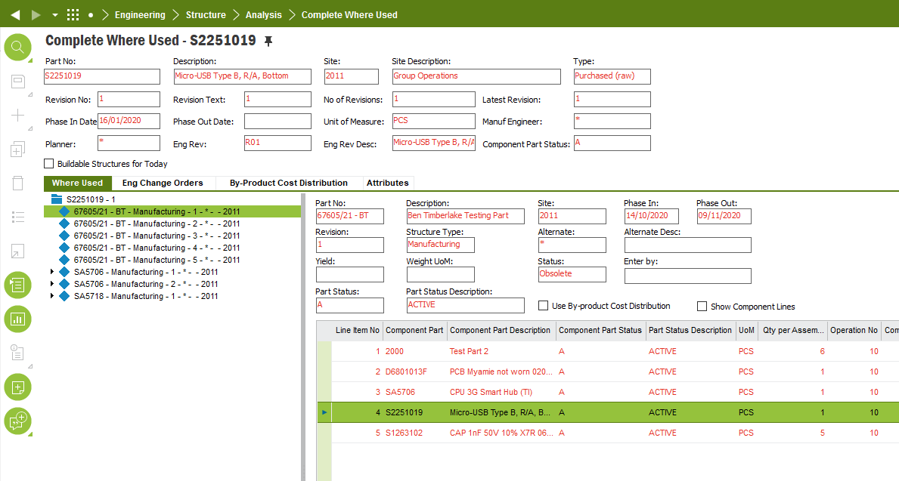

There is a navigator on the LHS giving all past Revisions of the assemblies that contain the searched Part and a windowpane on the RHS that gives the total Product Structure of the LHS highlighted Part including the searched for Part.

Please add a custom menu selection to the RMB off the header of this screen. This custom menu is to be called “CWU Report”. When this custom menu is selected it is to output a report that is a combination of the LHS side navigator and the RHS windowpane. This new report needs:

- To delete the older Revisions.
- To show the quantity of the searched for Part by the side of the Part that it is contained within.
- To also analyse down the Product Structure level so that if the searched for Part is used again in a lower level it is also shown in this report as per points 1) and 2) above.

Hence the CWU Report output would look similar to the LHS navigator but have the older Revisions deleted and the searched for Part quantities added:

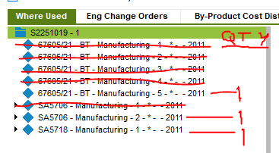
(Approved Amendments to Rev A1 by Email Communication – Added by LC as Part of Rev A2)

- Only Structure Type: Manufacturing and Prototype to be shown.
- Only show Revisions that have not been phased out. IE, Phase Out: (blank)

Further Specification per Rev A2:

The customisation as realised in Rev A1 was good for the requirements of Engineering. (The Rev A1 report shows the single level of where a Part is used.) However, Purchasing wish to see the multilevel. By this it is meant that they wish to see the single level of where a Part is used but also all the Product Structures above that, that also include that Part inside of that Product Structure.

Hence please:
- Create another menu choice off the RMB off the header to be entitled: “CWU Report Multilevel”
- Attach this new menu choice to a new QR that fulfils all the current specification or QR ID: 305309, but also includes all the single and multilevel with the Part quantities in a corresponding column. Hence to give an example in the same format as above:

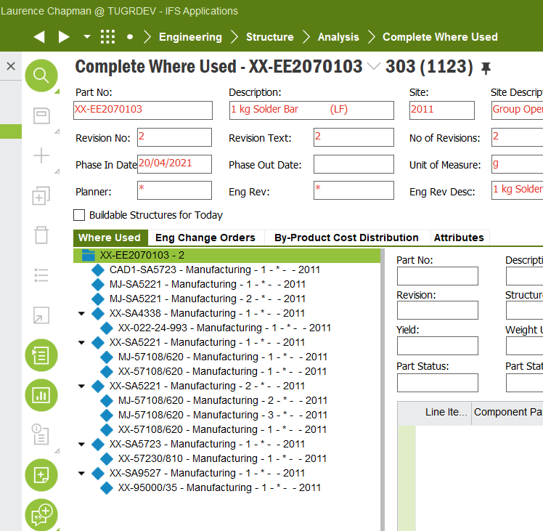

*Please note that where the big red asterisk is, these Revisions have not been phased out and would therefore still appear on this report as per the Approved Amendments to Rev A1 by Email Communication above.

Custom Field Requirement

Field definition
DB Column Name (if known) | Field Label | Insert | Mandatory | Update | Queryable | Zoom | Uppercase | List of Value | Format & Length | Comment and Reference
 |  | Y | N | Y | Y | N | N | Y |  | .

Delimitations
The modification in this specification will be developed explicitly as written. Requests for changes in the modification necessary to fulfil (or prepare for future fulfilment of) any requirements not explicitly described in the specification, will be considered outside the scope of this modification.
Translations other than stated under chapter translations are not included in the scope for this specification.
Customer IFS permission sets will be managed by the customer, unless as stated in a revision to this Functional Specification the customer requests new permission sets to be built to enable control of the customisation’s functionality.
Customer IFS profiles will be managed by the customer.
Changes or extensions on Online Help (F1 Help), e-learning material or process models are excluded from this specification.

TECHNICAL IMPLEMENTATION

Custom Menus
- CWU Report
- CWU Report Multilevel

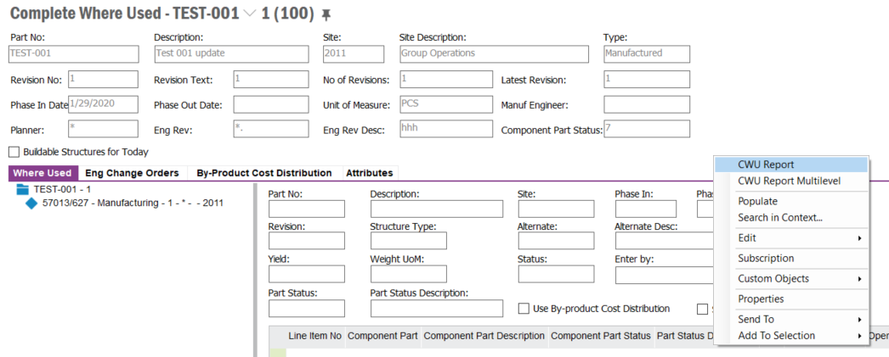

Quick Reports
CWU Report
CWU Report Multilevel

Translations

Prog Text | Translation | Window/form (optional) | Comment

Go Live Information/Upgrade Issues
Not Applicable.

Performance Considerations
The custom field should not hinder performance in reference to decreasing user performance and screen population time.

Glossary/Acronyms
Commonly used IFS terms within this specification include:
Term | Explanation
LOV | List of Values. This refers to a source list of records from which to select in a form.
RMB | Right Mouse Button. Commonly used abbreviation
LHS | Left hand side
RHS | Right hand side

Change log
Guidance: Delete section if no changes

Change log for revision XX

Guideline: Describe why the change order is needed (high level), and the sections of design affected by the changes. For lengthy specs, tag or mark the changed sections.

Change # | Chapter | Description of the change
1
2
3
n | 3.2 | <New column Z added to existing window>

Detailed description of Change #1

Detailed description of Change #n

1

